Start Morning:
if Saturday:
going in fishing:
else if Sunday:
read a book:
else:
going work:
End:
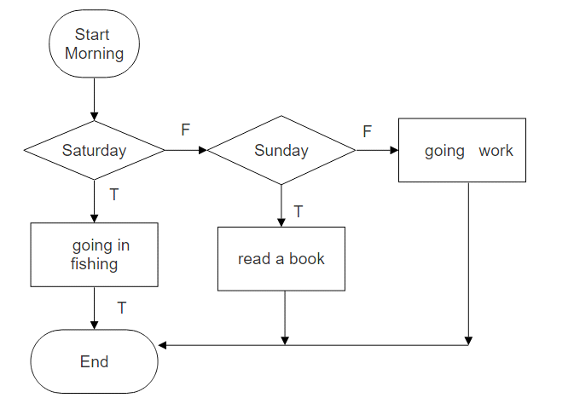

1. Draw flowchart

Start Morning:
if Saturday:
if time < 13:00:
going in fishing:
else if time = 18:00
watch football:
else if Sunday:
while time < 15:00:
read a book:
else:
watch TV:
else:
going work:
End:
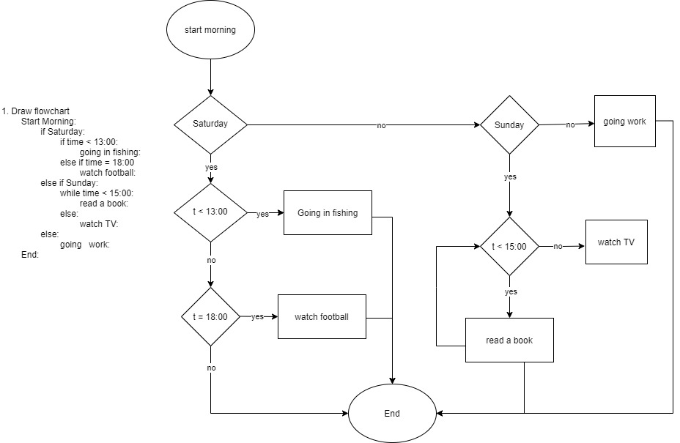

2. Draw flowchart
Start:
if time=13:00:
start lunch:
else if time = 14:00:
end lunch:
else:
while time<18:00
if time = 16:00:
meeting:
else:
work:
else:
home:
End:

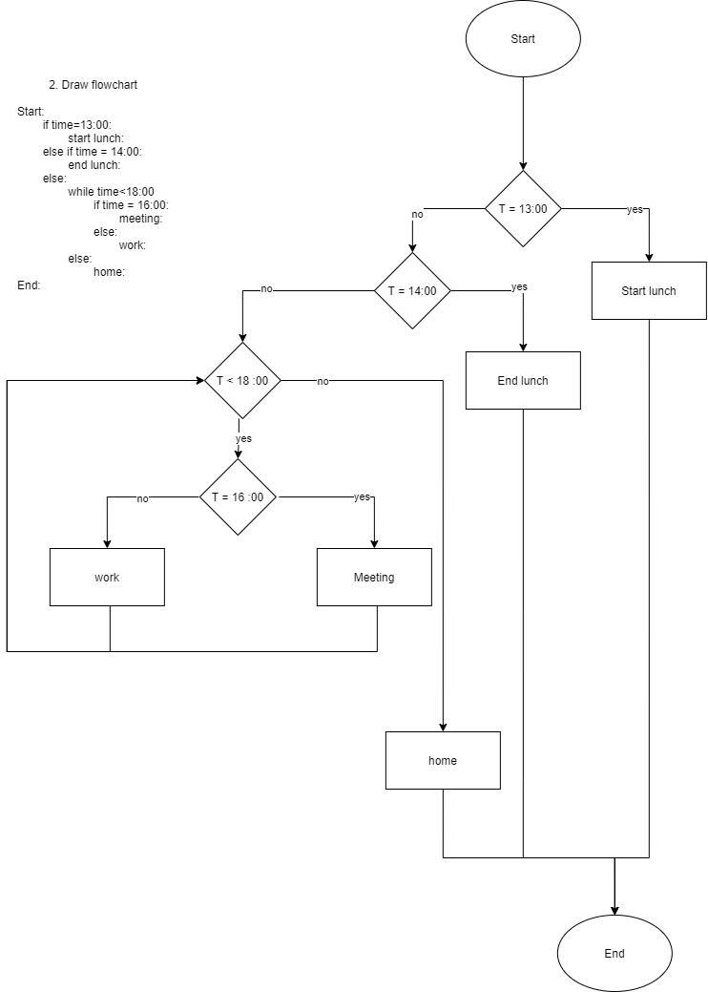

3. Create psedocode

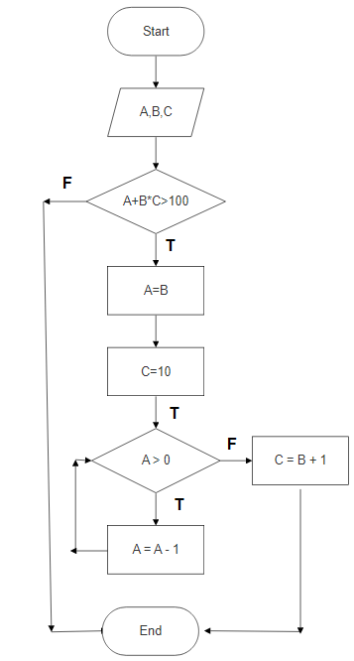
Start:
Read A,
Read B,
Read C,
if A+B* C > 100,
A=B
C=10
while A > 0,
A = A - 1,
else
C = B + 1,
End

Good job ☺

